



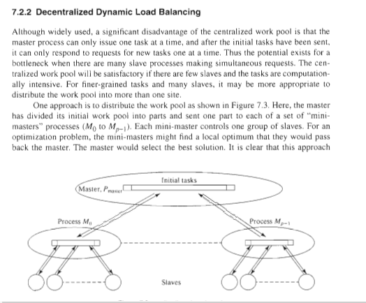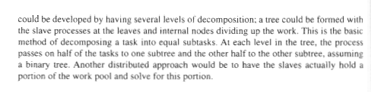

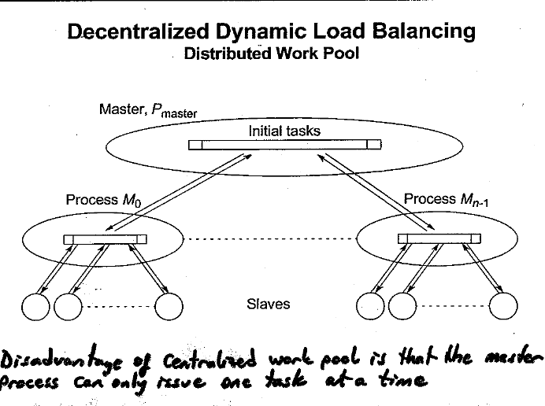

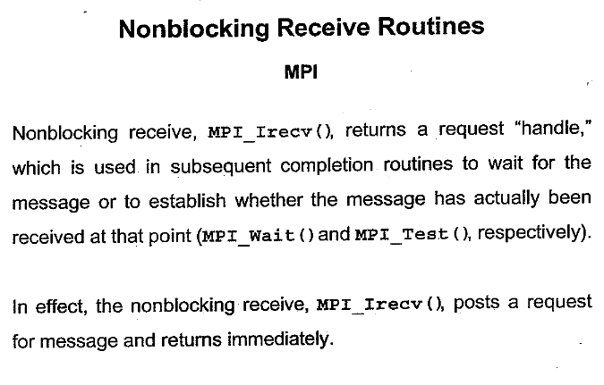

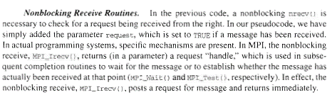

Source Book : Parallel programming by Barry Wilkinson



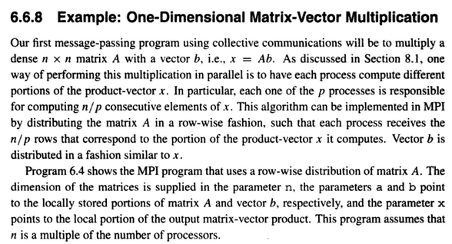

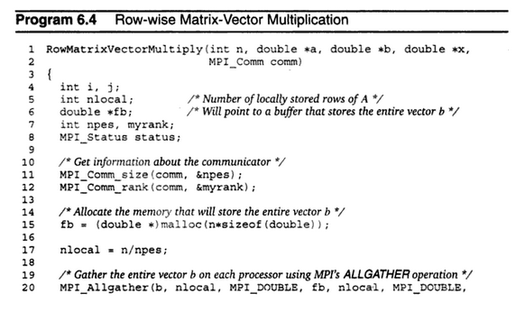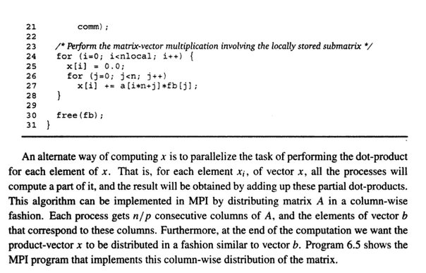

<https://books.google.co.in/books?id=wTV95NM8rJEC&pg=PA266&lpg=PA266&dq=message+passing+parallel+program+to+multiply+two+n+x+n+matrices&source=bl&ots=jwCFBj_iL3&sig=1q4NK4A6JQ770RBm3HHGOyWmxgE&hl=en&sa=X&ved=0ahUKEwjtmrirvrnXAhWKtY8KHSH-BVkQ6AEIQjAF#v=onepage&q=message%20passing%20parallel%20program%20to%20multiply%20two%20n%20x%20n%20matrices&f=false>

WRONG SOLUTION!!

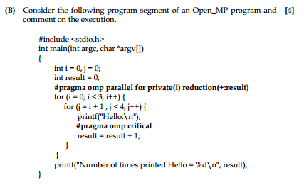

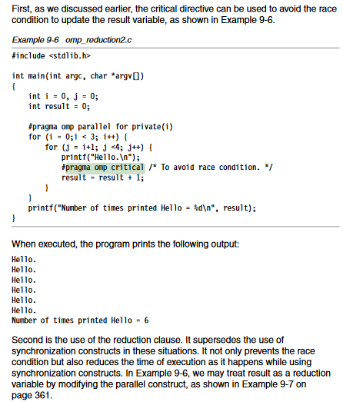

<https://www.redbooks.ibm.com/redbooks/pdfs/sg245674.pdf>



